# Introduction

## Purpose

This document represents the Requirement Analysis and Specification Document (RASD). Goals of this document are to completely describe the system in terms of functional and nonfunctional requirements, analyze the real needs of the customer to model the system, show the constraints and the limit of the software and indicate the typical use cases that will occur after the release. This document is addressed to the developers who have to implement the requirements and could be used as a contractual basis.

## Scope

### Description of the given problem

TrackMe is a company that wants to develop a service TrackMe is a company that wants to develop a software-­‐based service allowing third parties to monitor the location and health status of individuals. This service is called Data4Help. The service supports the registration of individuals who, by registering, agree that TrackMe acquires their data (data acquisition can happen through smartwatches or similar devices). Also, it supports the registration of third parties. After registration, these third parties can request:

###### Access to the data of some specific individuals (we can assume, for instance, that they know an individual by his/her social security number or fiscal code in Italy). In this case, TrackMe passes the request to the specific individuals who can accept or refuse it.

###### Access to anonymized data of groups of individuals (for instance, all those living in a certain geographical area, all those of a specific age range, etc.). These requests are handled directly by TrackMe that approves them if it is able to properly anonymize the requested data. For instance, if the third party is asking for data about 10-­‐year-­‐old children living in a certain street in Milano and the number of these children is two, then the third party could be able to derive their identity simply having people monitoring the residents of the street between 8.00 and 9.00 when kids go to school. Then, to avoid this risk and the possibility of a misuse of data, TrackMe will not accept the request. For simplicity, we assume that TrackMe will accept any request for which the number of individuals whose data satisfy the request is higher than 1000. As soon as a request for data is approved, TrackMe makes the previously saved data available to the third party. Also, it allows the third party to subscribe to new data and to receive them as soon as they are produced. Imagine now that, after some time, TrackMe realizes that a good part of its third-­‐party customers wants to use the data acquired through Data4Help to offer a personalized and non-­‐intrusive SOS service to elderly people. Therefore, TrackMe decides to build a new service, called AutomatedSOS, on top of Data4Help. AutomatedSOS monitors the health status of the subscribed customers and, when such parameters are below certain thresholds, sends to the location of the customer an ambulance, guaranteeing a reaction time of less than 5 seconds from the time the parameters are below the threshold.

### Goals

###### [G1] Allow a Visitor to become a Private Customer, after providing credentials, detailed personal information and accepting the terms of use of the service.

###### [G2] Allow a Visitor to become a Business Customer, after providing credentials and accepting the terms of use of the service.

###### [G3] Allow a Private Customer to subscribe to AutomatedSOS, after providing billing information and accepting the terms of use of the service.

###### [G4] Allow a Business Customer to request a subscription to Data4Help, after providing billing information.

###### [G5] Allow a Business Customer to monitor data from Data4Help.

[G5.1] Allow a BC to monitor the real time position and the health status of a PC, after requesting the permission.

[G5.2] Allow a BC to monitor anonymized data about PCs.

###### [G6] Allow a Business Customer to request data from Data4Help.

[G6.1] Allow a BC to request the real time position and the health status of a PC, by providing its SSN or CF.

[G6.2] Allow a BC to request anonymized data about PCs.

###### [G7] Allow a Private Customer to accept or refuse a request of sharing its real time position and health status by a Business Customer.

###### [G8] Allow a Business Customer to subscribe to a data source like a specific PC or a geographical area and receive them as soon as they are produced.

###### [G9] Allow a PC in serious health conditions to receive an ambulance in the shortest possible time.

###### [G10] Allow a System Manager to do operations of system maintenance.

[G10.1] Allow a SM to verify and accept the request of appliance from a BC.

###### [G11] Allow the mobile application to be capable of making emergency calls through a vocal synthesizer

## Definitions, Acronyms, Abbreviations

### Definitions

###### Private Customer: a customer that applies to the service Data4Help as a provider of personal health data.

###### Corporate or Business Customer: a customer that applies to the service Data4Help as a user of the data acquired.

### Acronyms

###### [BC] as Business Customer

###### [PC] as Private Customer

###### [SSC] as Social Security Number

###### [CF] as Codice Fiscale

###### [SM] as System Manager

###### [Gn]: n-goal.

###### [Dn]: n-domain assumption.

###### [Rn]: n-functional requirement.

## Revision History

## Reference Documents

## Document Structure

# Overall Description

## Product Perspective

## Product Functions

## User Characteristics

## Assumptions, Dependencies, Constraints

# Specific Requirements

## External Interface Requirements

### Hardware Interfaces

Data4Help requires the use of multiple hardware interfaces to be implemented properly. In the following paragraphs are described the platforms and technologies on which this system will be based on.

###### Android Smartphone with Bluetooth, LTE and GPS that allow Data4Help application to run on the Private Customers phone and be able to communicate via internet with the remote Data4Help servers and via Bluetooth with the wearable of the Private Customer.

###### Wearable device with hear beat sensor and blood pressure sensor running Android Wear that be mainly devoted to acquiring body data form its sensors and sending them to the Private Customer’s Android Smartphone.

###### Remote Server that be hosting the web platform used to present data to Business Customers, and the backend of the mobile application. It needs to be connected to a high-speed symmetric internet connection.

### Software Interfaces

Data4Help will be developed on top of existing software:

###### JVM core library and JavaFx.

###### Google Play Services are needed to communicate to the Private Customer’s Android smartphones.

###### A third-party vocal synthesizer library that will be used to create the vocal message that will be red automatically to the Emergency phone line.

###### MySQL as the primary DBMS

### Communication Interfaces

Data4Help being a service based on multiple hardware interfaces needs obviously interconnectivity between them. Two interfaces will be used:

###### Bluetooth (ACL protocol), to exchange data between the Private Customer’s Wearable and Smartphone.

###### HTTPS or Java Object Serialization on top of TCP to exchange data between the backend and the Private Customer’s Smartphone and between the Business Customer’s web application (desktop Java Application)

###### Google Play Services API’s to be able to send notification to the Private Customer’s phone.

## Functional Requirements

## Non-Functional Requirements

### Performance

The system of Data4Help needs to be able to handle multiple connection without any latency. Initially the system will be developed whit the capability of handling 10.000 Private customers simultaneously and a 1000 Business Customers.

Business Customers will be able to:

###### Inspect in real time the data acquired of a specific Private Customer, always according to the privacy policy defined in the goals above[G5.1].

###### Make 5 anonymous query per day to the database of Data4Help. The result of those will be available in less than 24h.

The system will also provide a 5 seconds response time from the detection of an emergency situation via the wearable Private Customer’s device to the start of the call to the emergency phone line. (Only for AutomatedSOS subscriber).

### Reliability

The system needs to be online 24/7. Data4Help will be implemented traditionally, trusting the reliability of a single server. AutomatedSOS core given the importance of its function will be implemented on redundant servers positioned in different locations allowing the maximum possible degree of reliability.

### Security

The system needs to be secure booth from the physical (Secure server room) and the digital perspective.

The Client’s data needs to be encrypted with AES.

All the connections through internet must be protected with TLS over HTTP.

### Scalability

The system needs to be scalable as the userbase might increase over the initial design limit.

### Accuracy

The hardware must provide accurate health data to render possible the implementation of AutomatedSOS functionality, lives will be dependent on this service.

GPS precision needs to be in order the of 10 meters to allow an effective rescue in case of emergency.

# Scenarios

## Scenario 1

Julia, unfortunately, has a rare disease. Due to this condition her health parameters need to be checked frequently by a medical equip. Thanks to Data4Help Julia can lead a normal life without worrying about going very often to a hospital. She is registered to Data4Help as a Private Customer and her equip as a Business Customer. Julia accepted the request from the medical equip to allow the real time monitoring function.

Now she can enjoy a normal life.

## Scenario 2

Carlos works for a public hospital in Milan, he is an analyst and having precise health data of the people living in Milan can help him in his last research on air pollution. A colleague tells him that the hospital now is a Business Customer of Data4Help and informs him about the possibility of querying the Data4Help database to gather anonymous health data of the population of a certain area. Carlos is amazed by this information, the next day his superior will give him the credentials to use Data4Help’s service. After downloading Data4Help’s desktop client software he can immediately start filling the “anonymous query” form. In the 24 hours succeeding the submission he will receive a notification on his desktop and the asked data will be available for consultation.

## Scenario 3

Emilio has a very old mother. He always worries her thinking that something may happen to her when she’s alone. After an internet research he comes to know that Data4Help has recently opened to the public a service called AutomatedSOS that provides immediate rescue in case of swoon or hearth attack. He immediately thinks that this seems tailored to his needs. After talking with her mother, Emilio downloads the Data4Help app on her Android smartphone and buys her a smart watch capable of monitoring blood pressure and hearth rate. He registers his mother to Data4Help on the app as a Private Customer and then purchase a subscription for AutomatedSOS. From now on he will sleep peacefully not worrying about his mother health condition.

# Uml modelling

## Use case descriptions

### Visitor registration as a Private Customer

|  |  |
| --- | --- |
| Actors | Visitor |
| Goals | [G1] |
| Input Conditions | The visitor has downloaded the Android application on its smartphone |
| Event Flow | 1. The visitor clicks the “sign in” button in on the Android app 2. The visitor fills the forms with the required personal information such as: e-mail, password, name, surname, CF or SSC, age, sex and birth place and date. 3. The system checks for duplicates and correctness of the data provided. 4. The visitor clicks “Confirm and Accept the terms and conditions of use” 5. The system saves its information and sends a verification email to its address. 6. The visitors verify its e-mail by clicking on the link sent to its address. |
| Output Conditions | The visitor now is a new Private Customer and it can Login on to the application and star using Data4Help’s services |
| Exceptions | 1. The visitor provides some identifying information already present in the system. (e-mail or CF or SSC) 2. The visitor provides inconsistent data such as not matching CF to personal data.   These exceptions are handled by notifying the visitor the specific issue and presenting again a form to fill. |

### Visitor registration as a Business Customer

|  |  |
| --- | --- |
| Actors | Visitor |
| Goals | [G2] |
| Input Conditions | The visitor is on the web page of Data4Help |
| Event Flow | 1. The visitor clicks on “Register as a Business Customer” button on the main web page of Data4Help. 2. The visitor provides all the information regarding its business, e-mail and password. 3. The system checks for duplicates and inconsistencies in the provided data. 4. The visitor clicks on “Confirm and Accept the terms and conditions of use”. 5. The visitors verify its e-mail by clicking on the link sent to its address. |
| Output Conditions | The visitor now becomes a new Business Customer enabling it to request a subscription to Data4Help |
| Exceptions | 1. The visitor provides some identifying information already present in the system. (e-mail, EIN or p.IVA).   These exceptions are handled by notifying the visitor the specific issue and presenting again a form to fill. |

### Accepting Business Customer’s requests of subscription to Data4Help

|  |  |
| --- | --- |
| Actors | System Manager |
| Goals | [G10.1] |
| Input Conditions | The System Manager must be logged in to the maintenance system. |
| Event Flow | 1. The system manager selects a request to process on the list presented on the main page of the maintenance system. 2. The system does a manual check on the information provided by the Business Customer 3. The system manager accepts the request. 4. The system requests a payment trough a third-party billing service. 5. If the payment is accepted the system update its information about subscribed Business Customers. |
| Output Conditions | The Business Customer is now a subscriber of Data4Help, allowing it to access all the functionalities offered by the platform. |
| Exceptions | 1. The system manager finds an inconsistency in the information provided 2. The payment doesn’t go through   In these exceptions the system manager must manually contact the Business Customer to resolve the issues. |

### 

## Use case diagrams

### Use case visitor

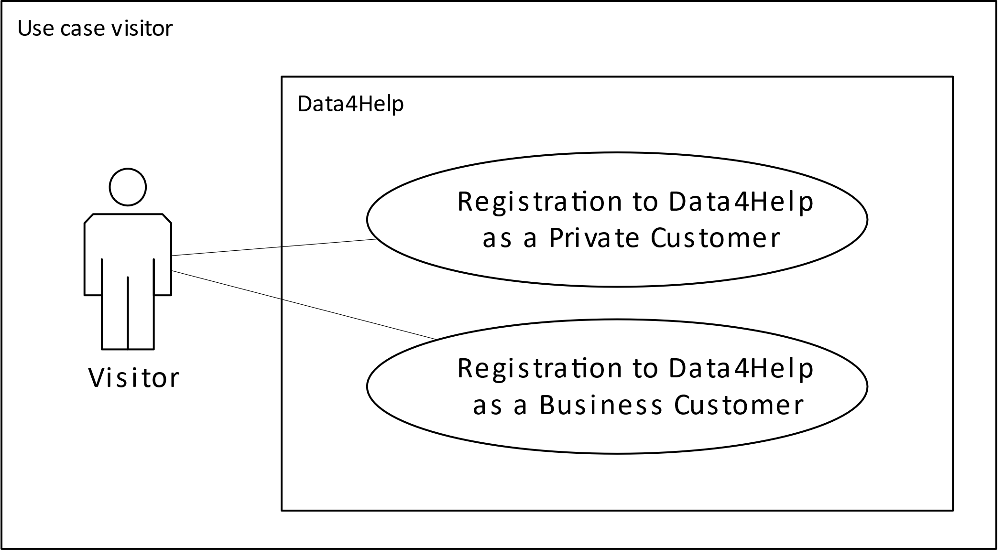

### Use case system manager

### 

### Use case Business and Private customers